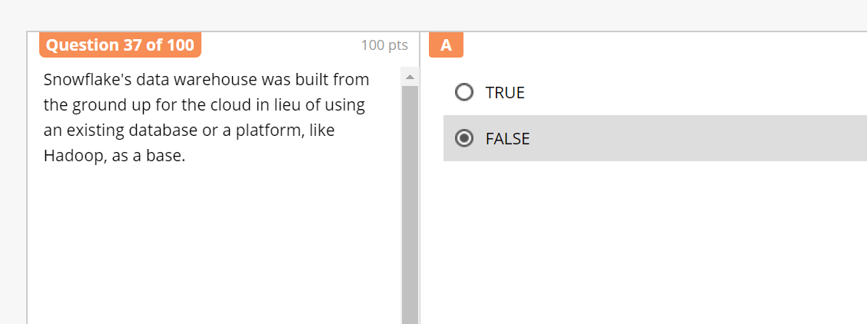

**True**

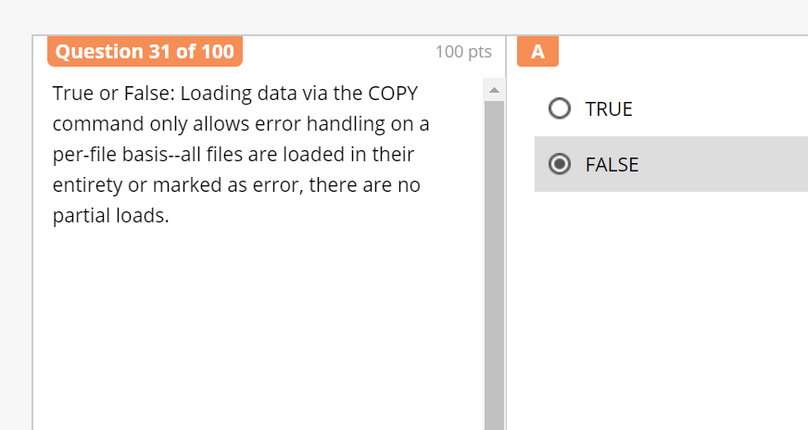

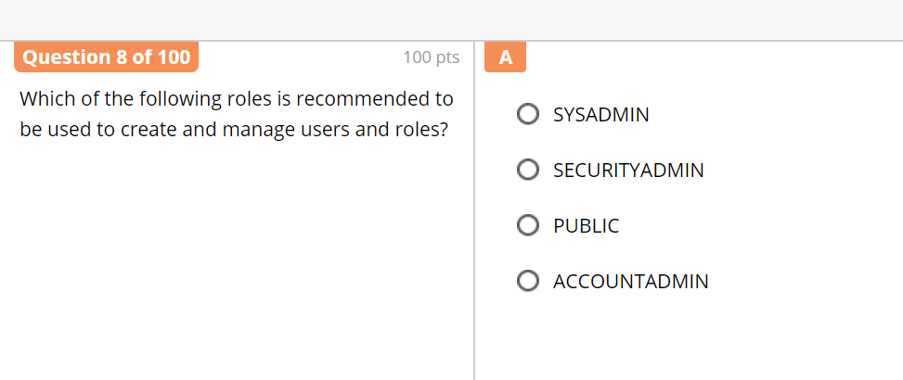

Answer is **SECURITY ADMIN**

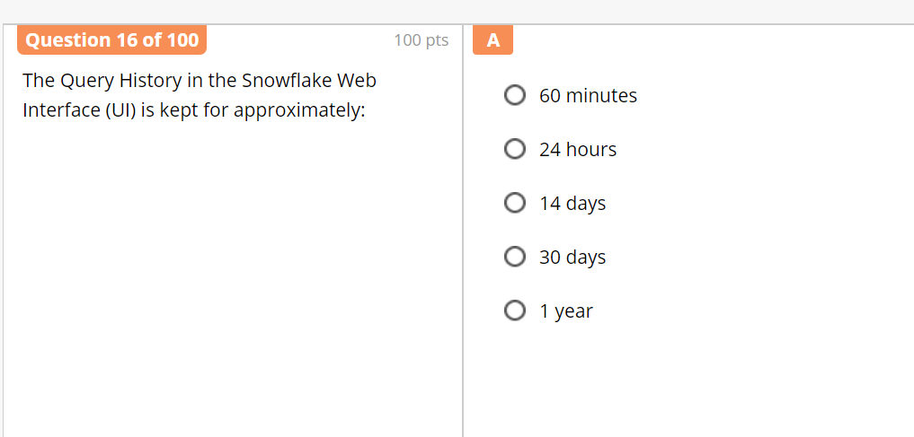

Answer is **14 Days**

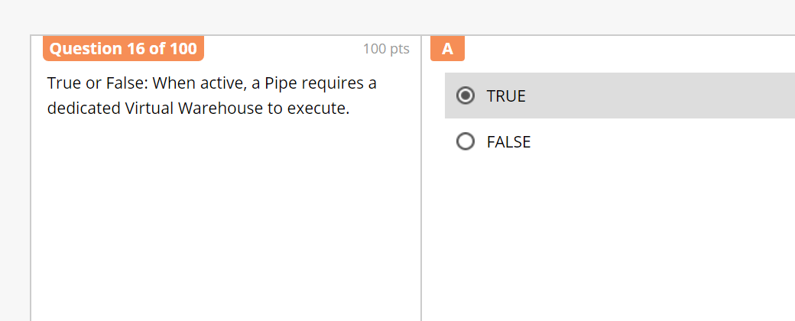

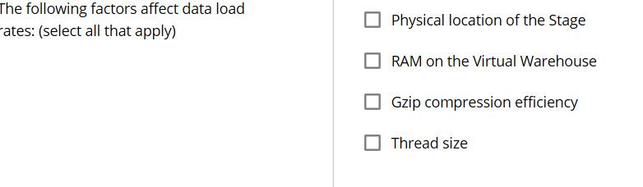

**Physical Location of the stage affect load rate**

**Gzip compression efficiency**

**Thread size**

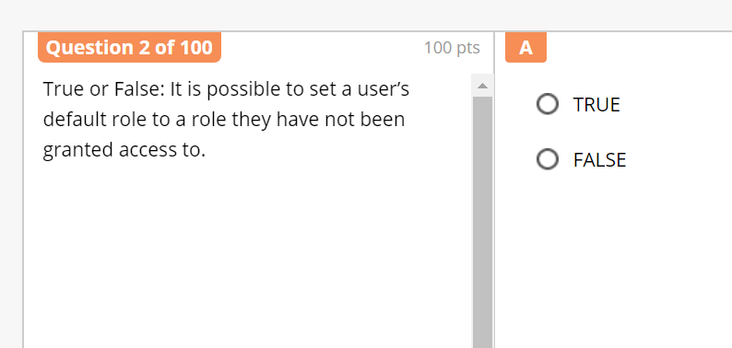

Correct Answer is **TRUE**

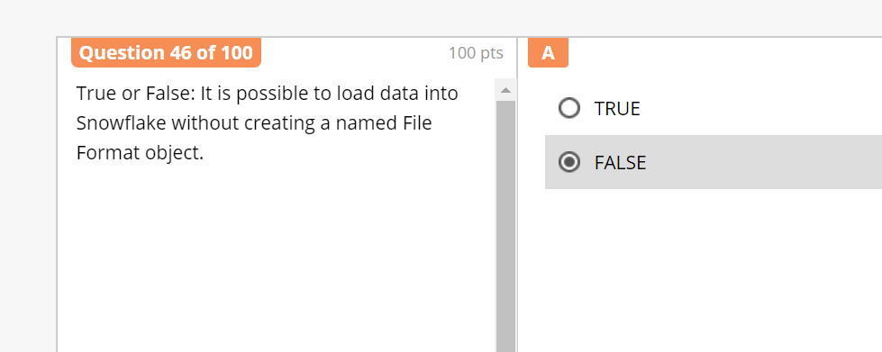

Correct Answer is **TRUE**

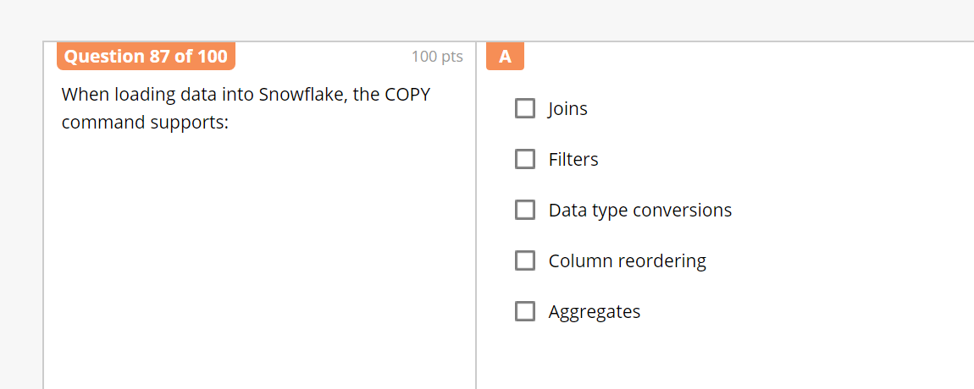

Correct Answer is **Data type conversions & Column reordering**

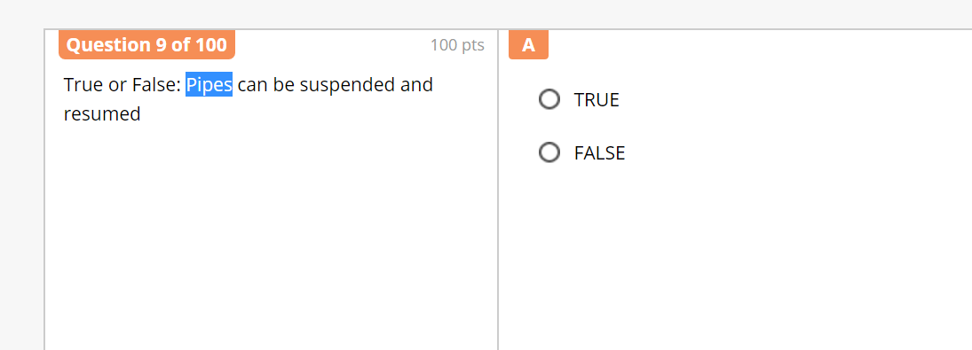

Correct Answer is **TRUE**

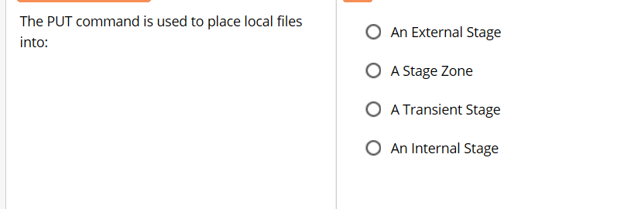

Correct Answer is **Internal Stage**

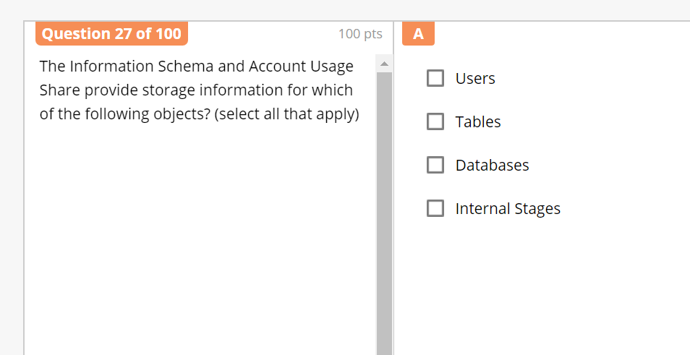

Correct Answer is **Tables, Databases & Internal Stages**

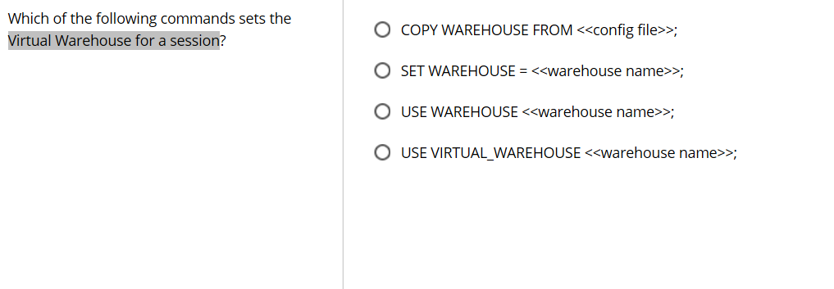

Correct Answer is **USE WAREHOUSE <<warehouse name>>**

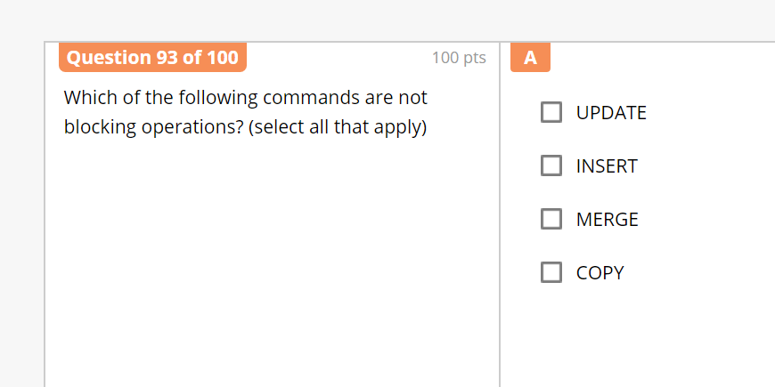

Correct Answer is **INSERT & COPY**

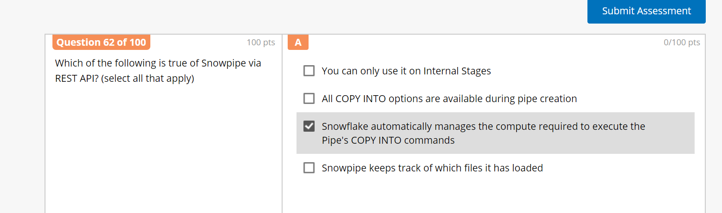

Correct Answer is **2, 3, 4 Options. (**All copy options available, Snowflake automatically manages & keeps track of which files loaded**)**

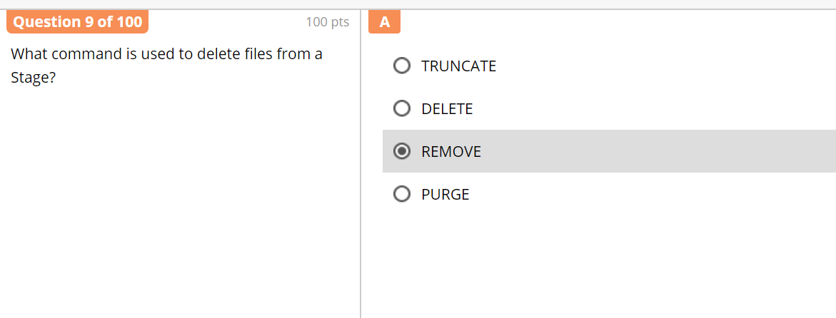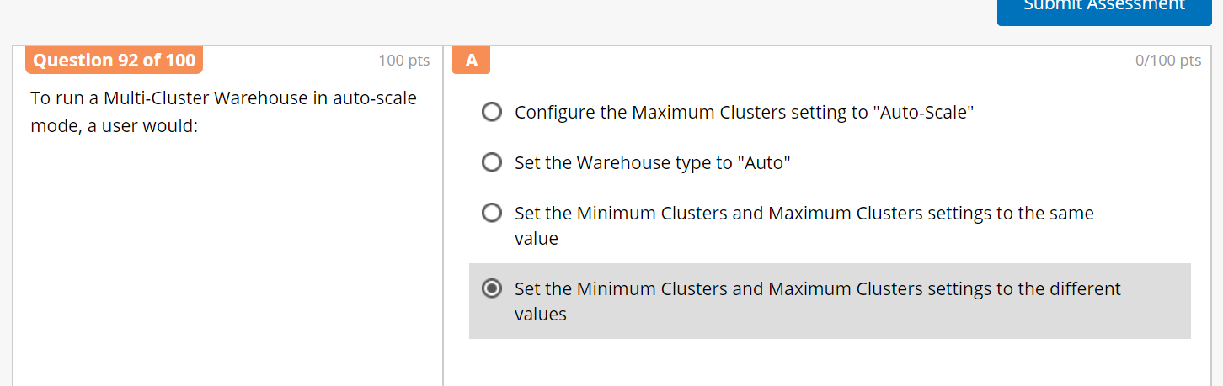

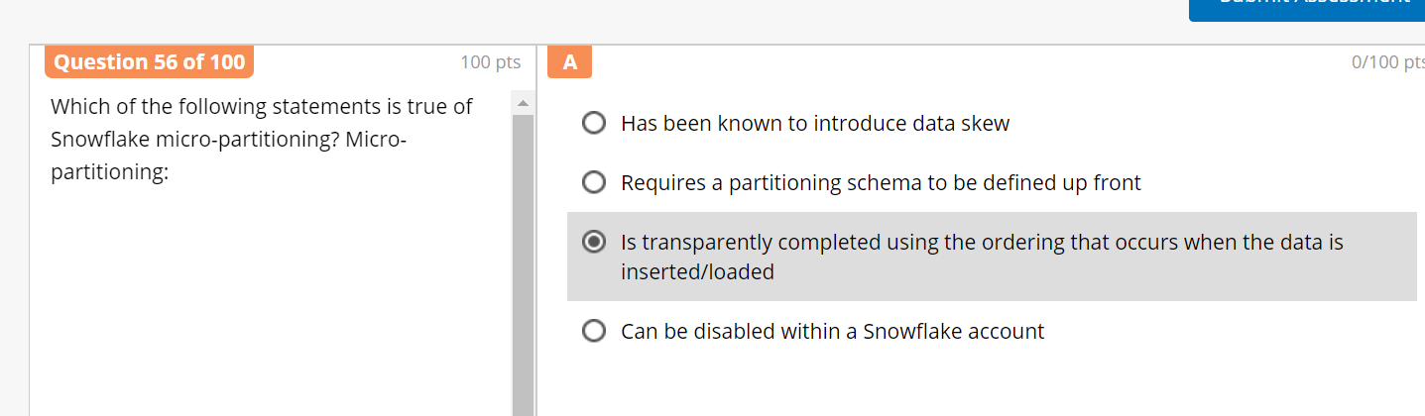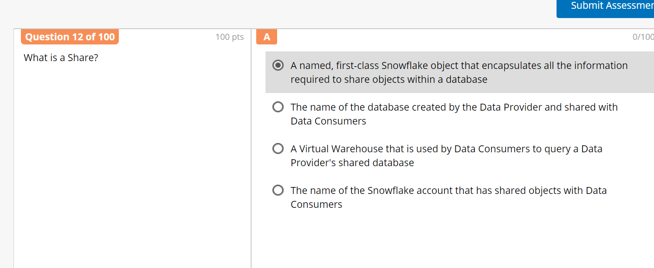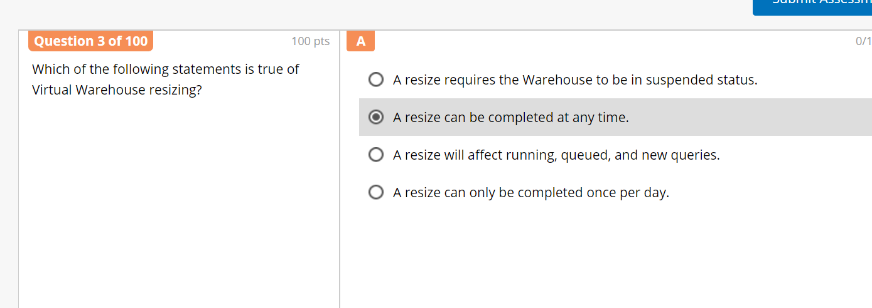

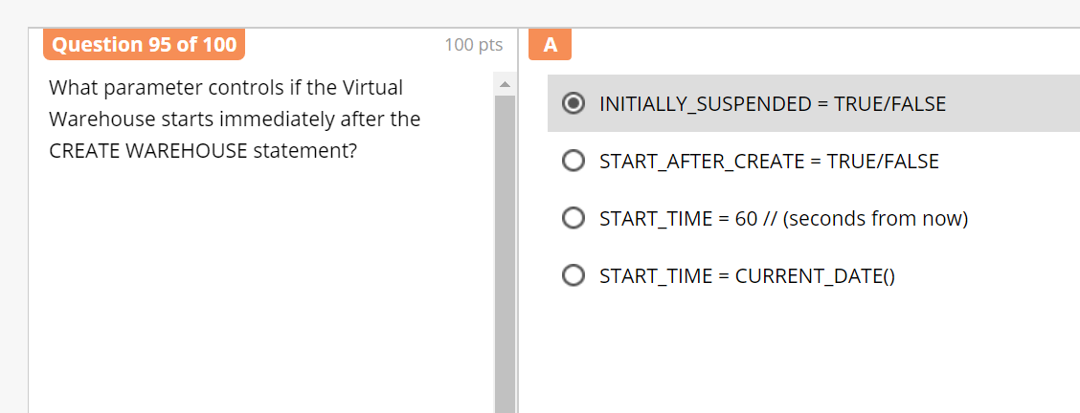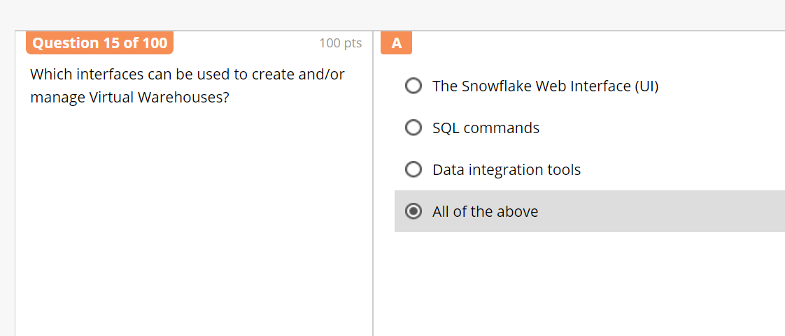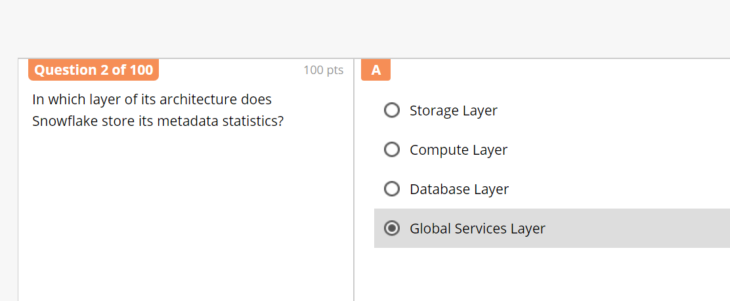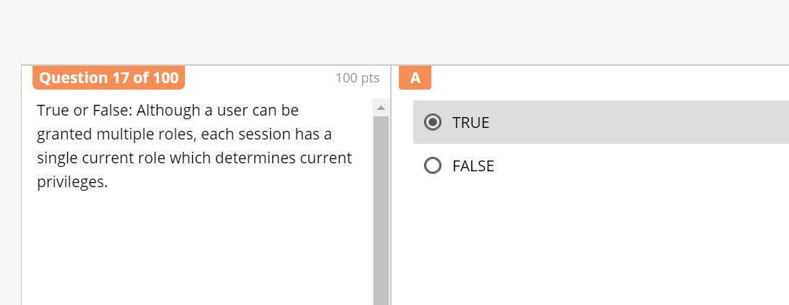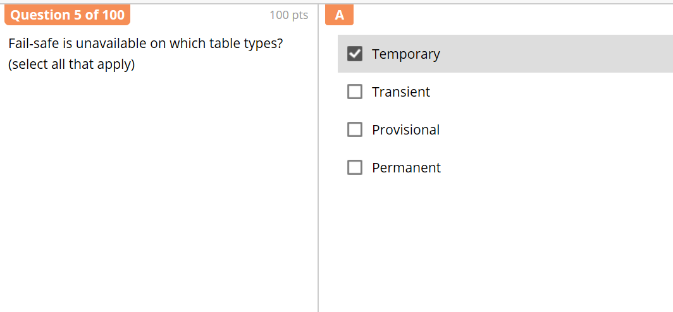

Correct Answer is **Temporary & Transient**

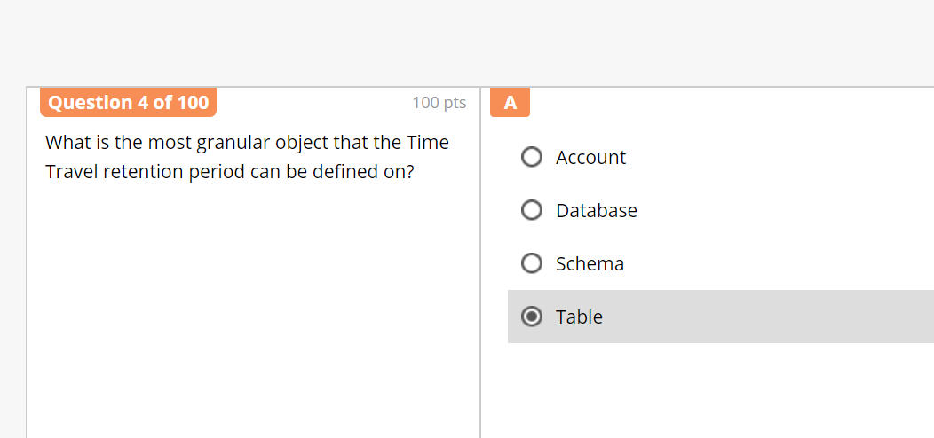

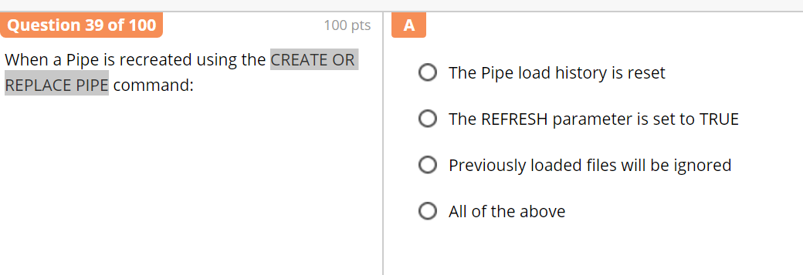

Correct Answer is **Pipe load history is reset**

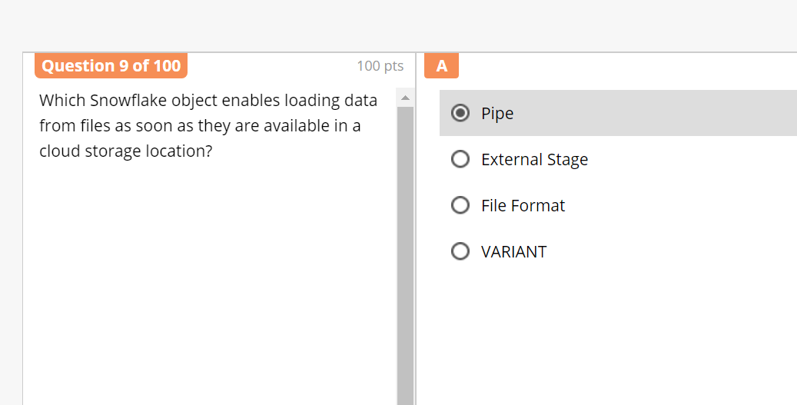

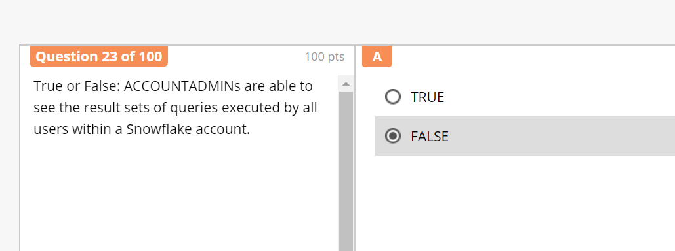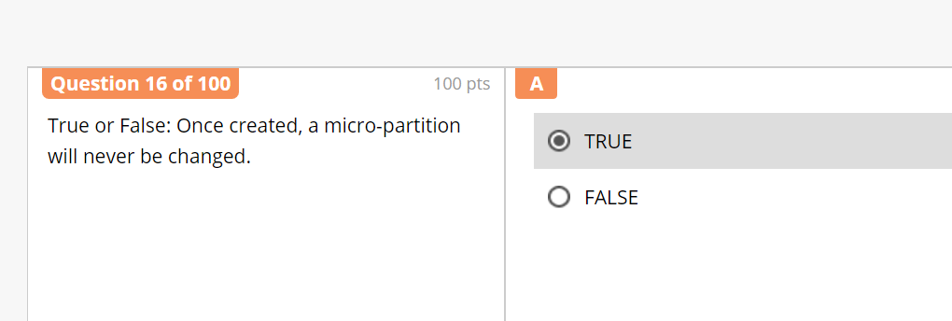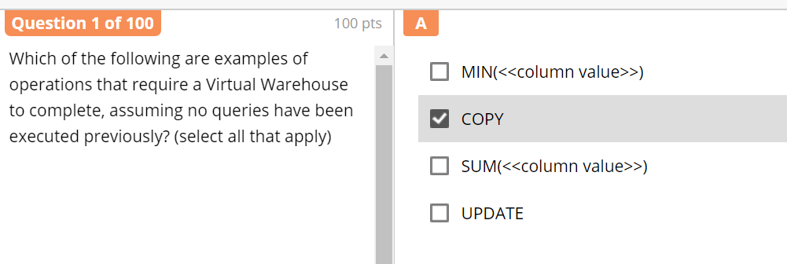

Correct Answer is **COPY, SUM & UPDATE**

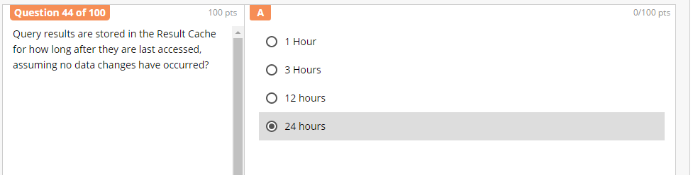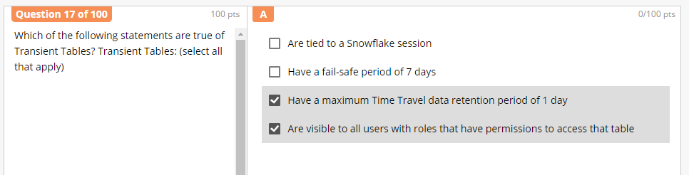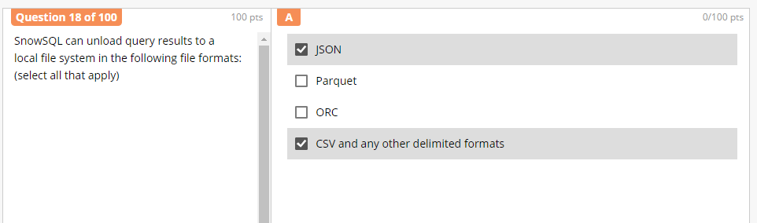

Correct Answer is **JSON, Parquet, CSV & any other delimited format (**concatenated delimiter values are not supported)

**For loading, ORC is also allowed**

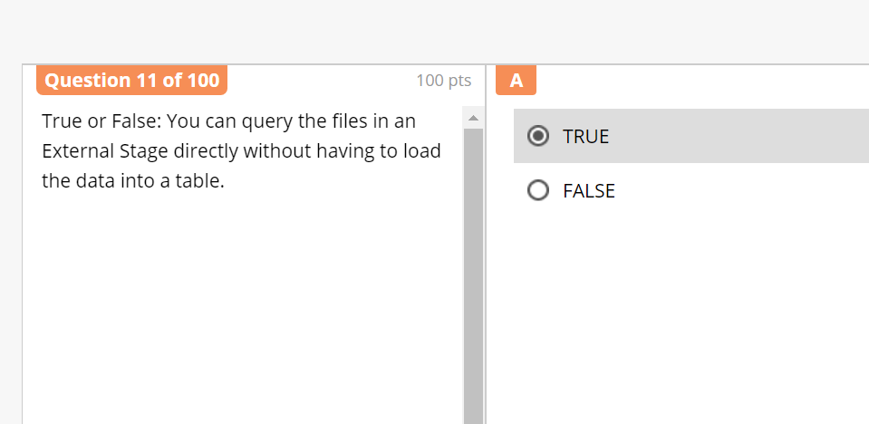

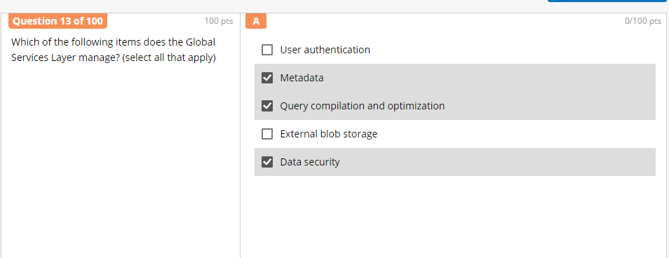

Correct Answer is **User Authentication, Metadata, Query comp* & optimization and Data Security**

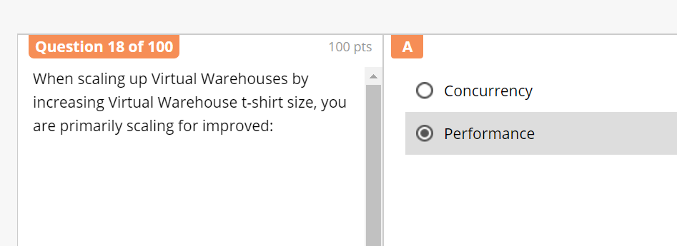

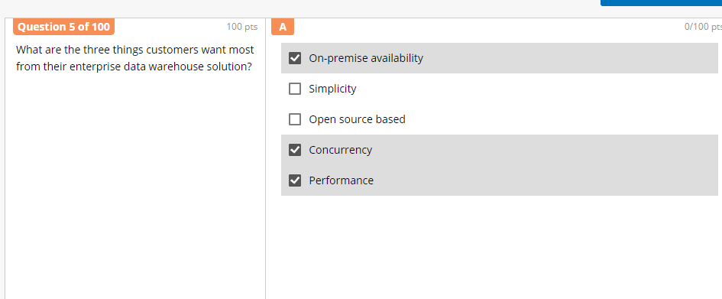

Correct Answer is **Simplicity, Concurrency & Performance**

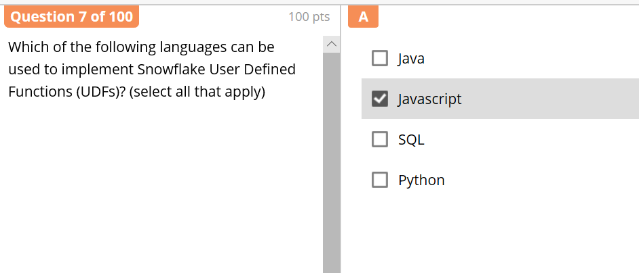

Correct Answer is **JavaScript & SQL**

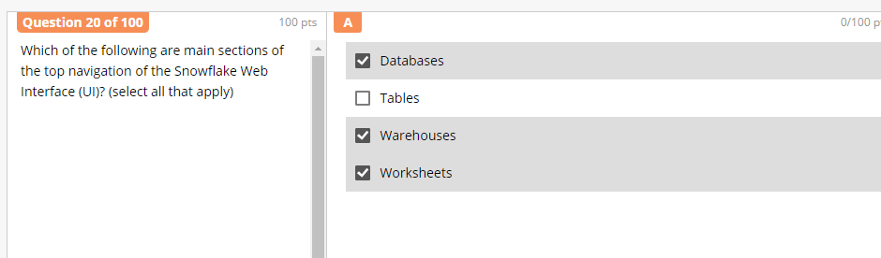

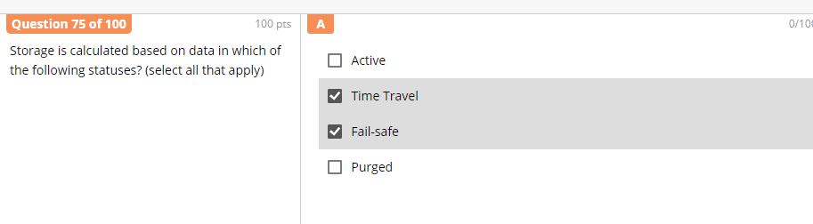

Correct Answer is **Active, Time Travel & Fail-safe**

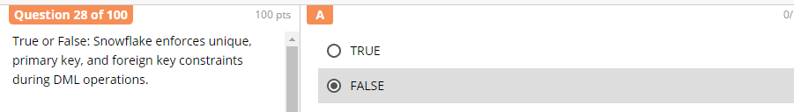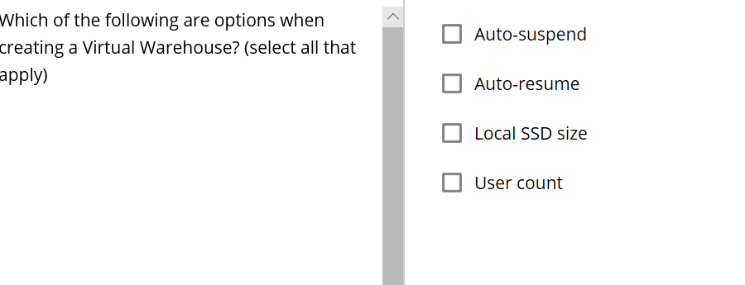

Correct Answer is **Auto Suspend & Auto Resume**

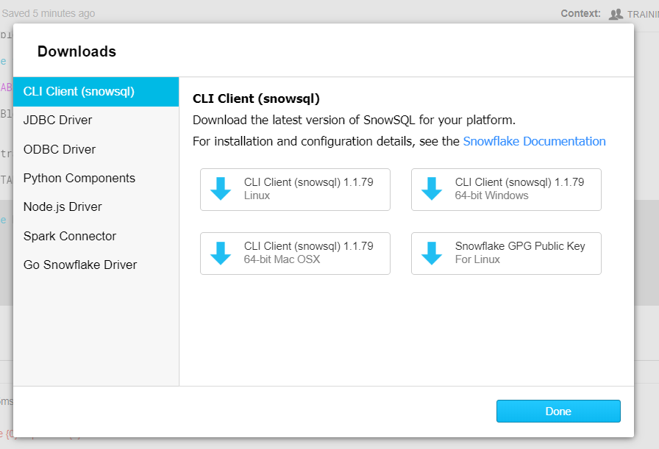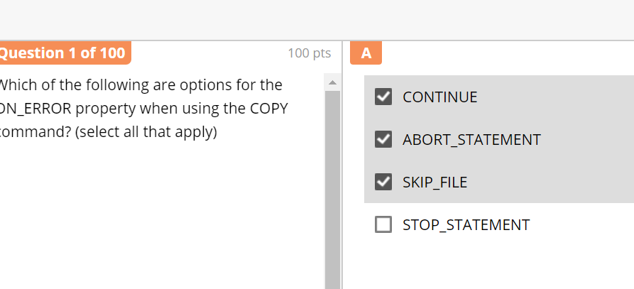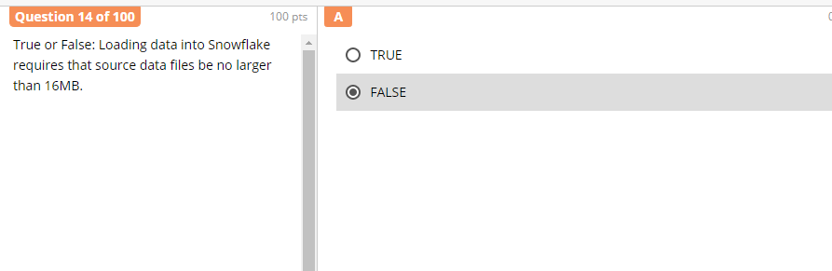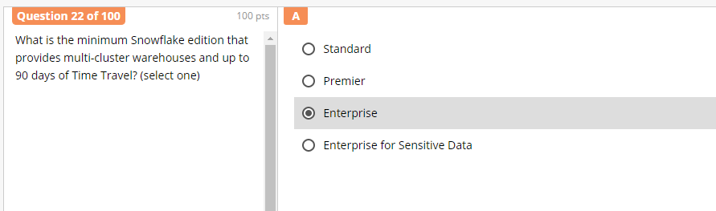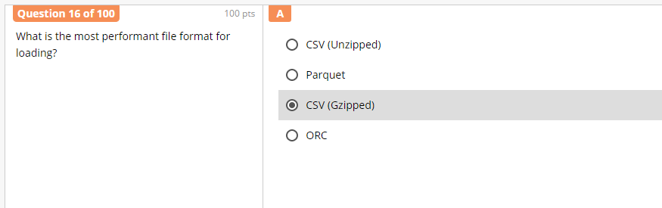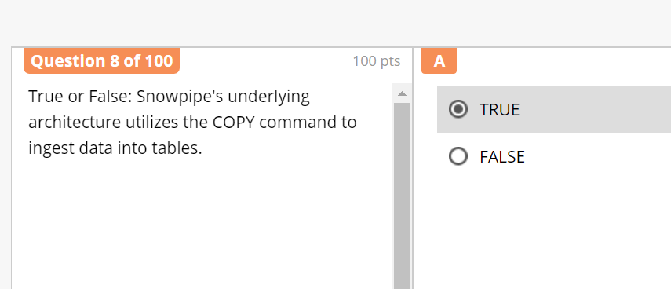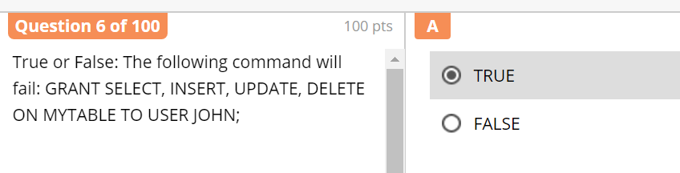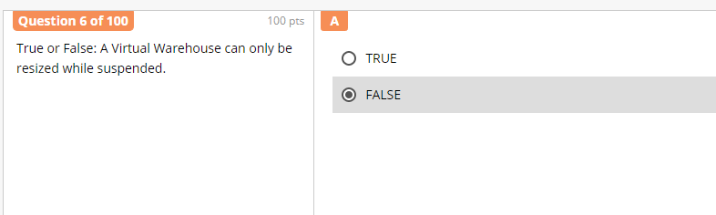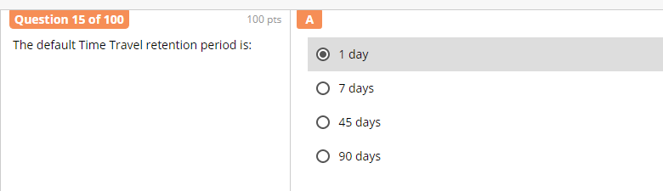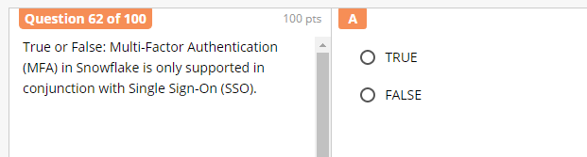

Correct Answer is **TRUE**

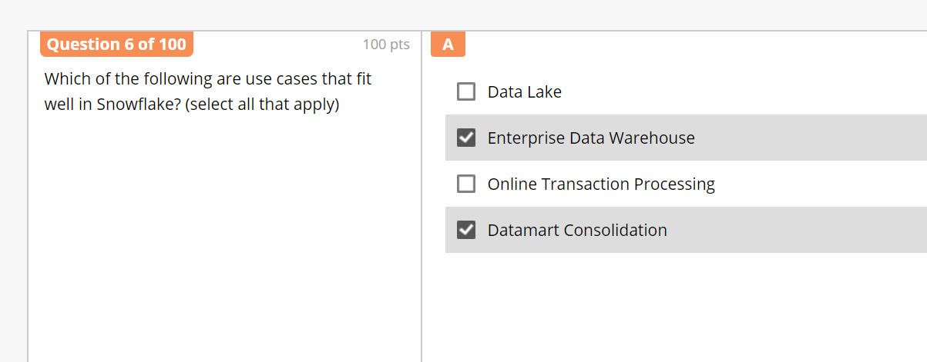

Correct Answer is **Data Lake, EDW & DataMart**

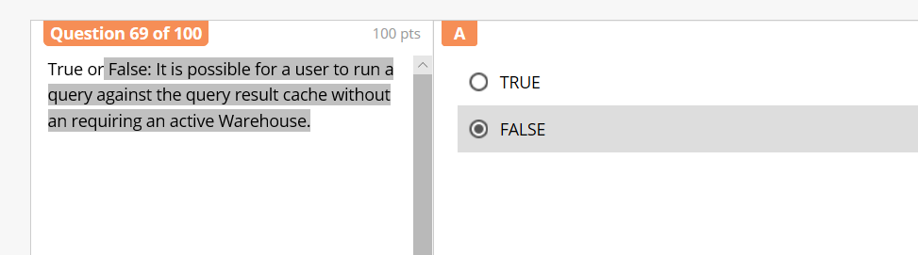

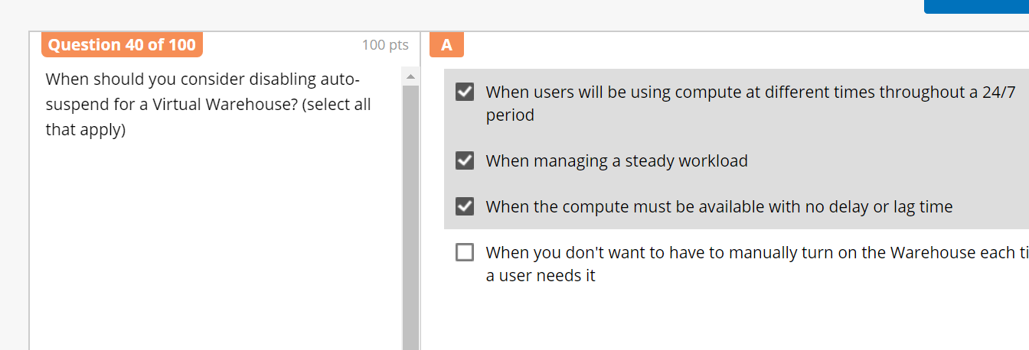

Answer 2nd & 3rd

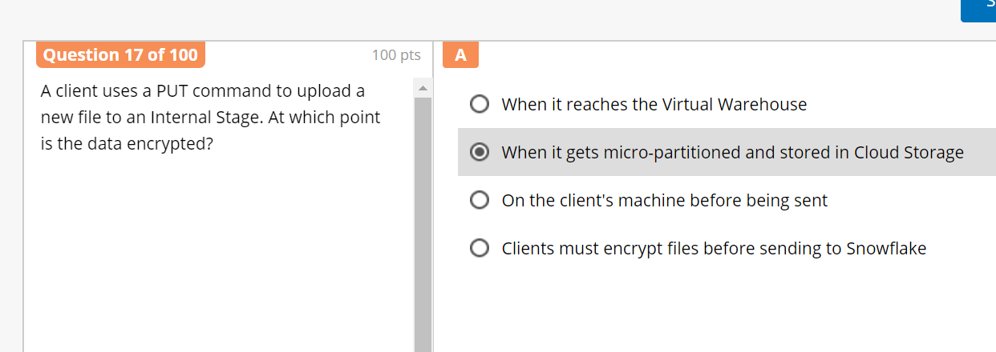Correct Answer is **on the client machine before being sent** 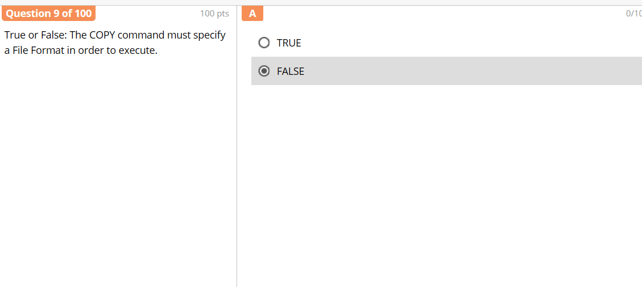

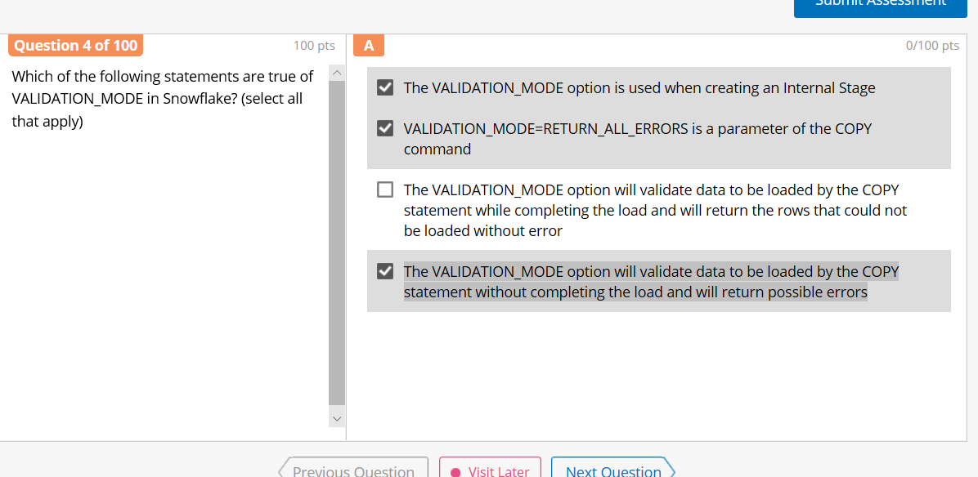

Correct Answer is **2 & 4 (RETURN_ALL_ERRORS, copy stmt without completing the load, will return all possible errors)**

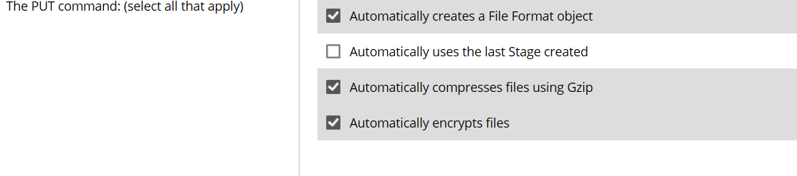Correct Answer is **3 & 4** **(Compresses files using Gzip & encrypts files)**

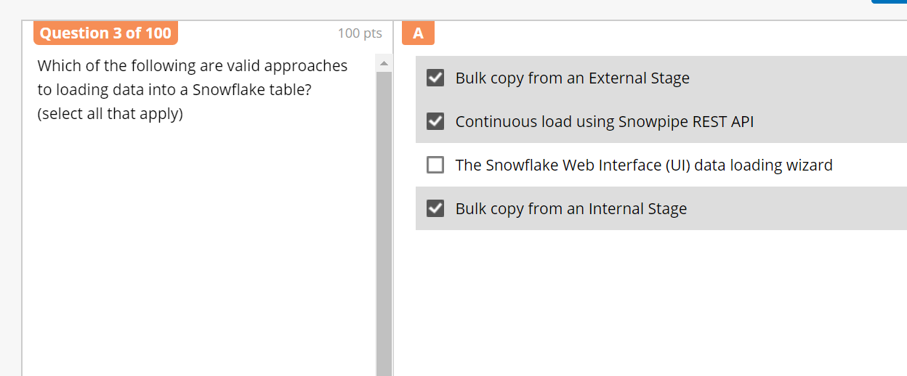

Correct Answer: **ALL (**including Web Interface**)**

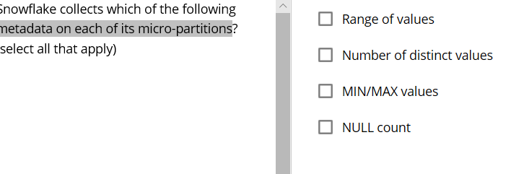

Correct Answer: **ALL** **(Range, No. of Distinct values, Min/Max, NULL)**

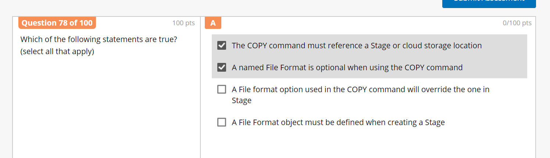

Correct Answer: **1, 2&3 (**reference a stg or cloud storage loc, named file format is optional & file format used in copy cmd will override the one in stg**)**

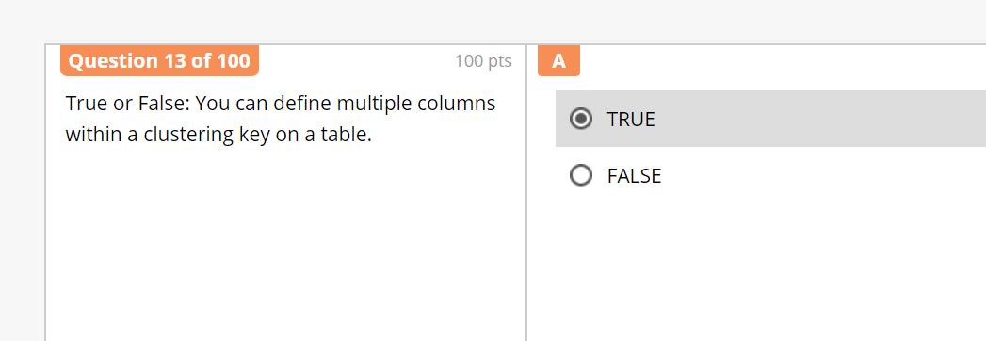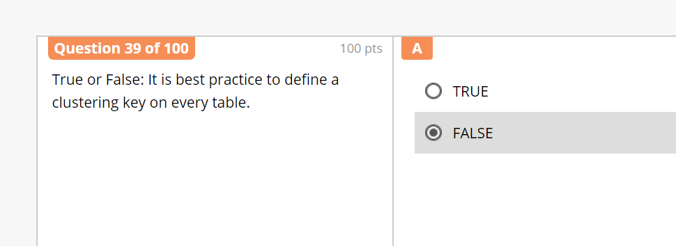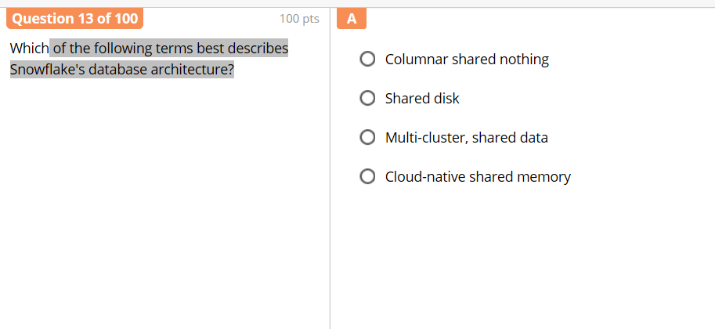

Correct Answer is **Multi-cluster, Shared data**